Activity No. 1.1
Using Pseudo-code Statements and Flowchart Symbols
Course Code: CPE010 | Program: Computer Engineering
Course Title: Using Pseudo-code Statements and Flowchart Symbols | Date Performed: August 2, 2025
Section: CPE11S1 | Date Submitted: August 3, 2025
Name(s): Jaime Luis M. Demain | Instructor: Jimlord Quejado
6. Output
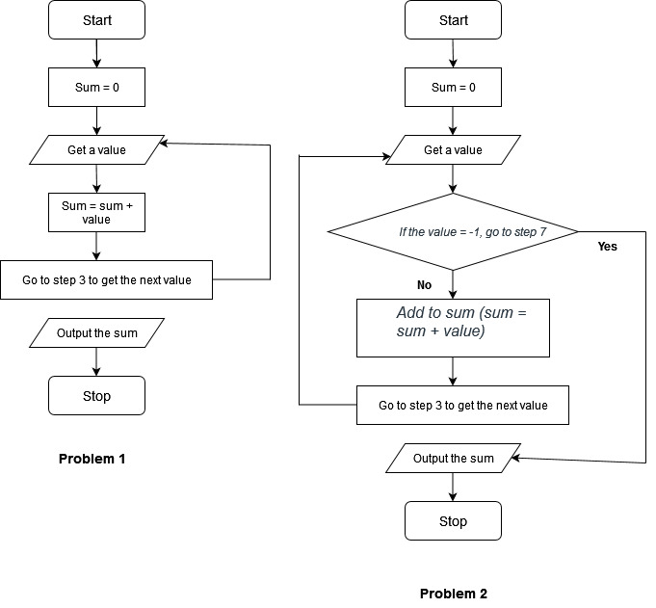

7. Supplementary Activity
1.
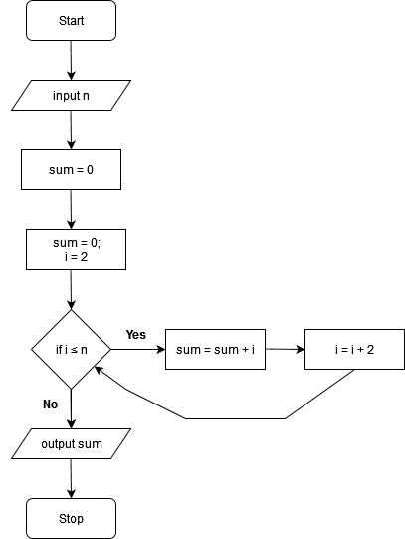
2.
start
Sum = 0
Count = 1
If count ≤ 100
Then input #
Sum = sum + #
Count = count + 1
Else output sum
stop
3.
start
(1st value = 0)
(2nd value = 0)
Input 1st value
Input 2nd value
If 1st value > 2nd value
Then output 1st value
Else output 2nd value
stop
4.
start
Input number1
Input number2
If number1 < number2
Then output number1
Else output number2
stop
5.
start
Input number1
Input number2
Input number3
Largest = number1
If number2 > largest
then largest = number2
If number3 > largest
then largest = number3
Output largest
stop
6.
start
Input first number
Largest = first number
Count = 0
If count < 100
(Then input number
If number > largest
Then set largest = number
Count = count + 1)
Else output largest
stop
8. Conclusion
9. Assessment Rubric

